Ideation Phase
Empathize & Discover

Date | 31 January 2025
Team ID | SWTID-2026-6491
Project Name | Import Data Using Transform Maps
Maximum Marks
Maximum Marks | 4 Marks

Empathy Map Canvas:
An empathy map is a simple, easy-to-digest visual that captures knowledge about a user’s behaviours and attitudes.

It is a useful tool to helps teams better understand their users.
Creating an effective solution requires understanding the true problem and the person who is experiencing it. The exercise of creating the map helps participants consider things from the user’s perspective along with his or her goals and challenges.
Example:
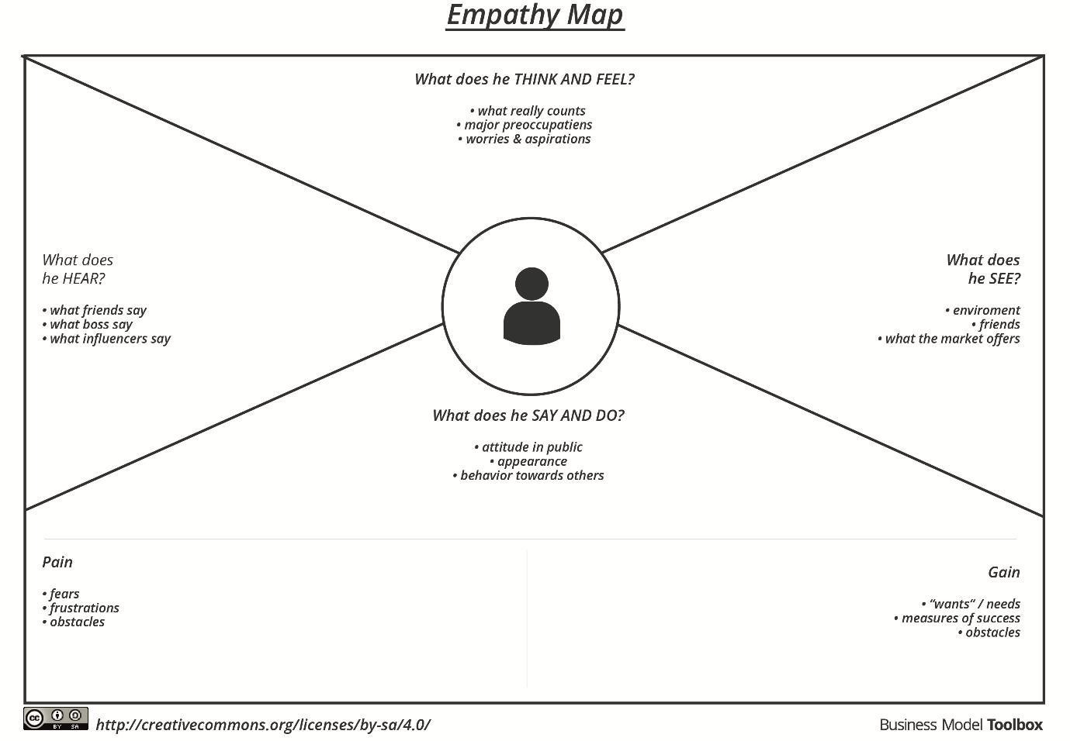

Reference: https://www.mural.co/templates/empathy-map-canvas

Pain |  |  |  | Gain
  Accuracy |  | Consistency
 | Imp | ort failures
  Incorrect field mapping |  | Duplicate records
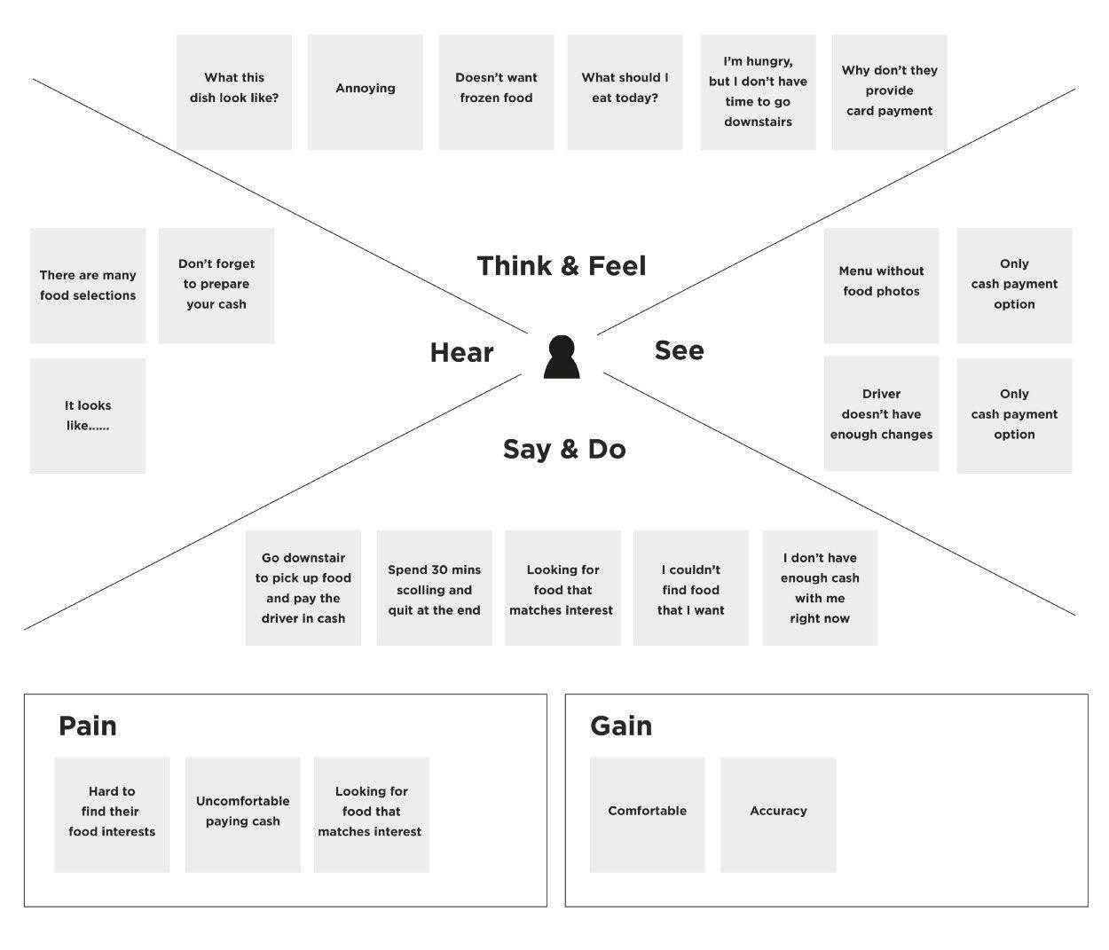
Example:Empathy Map: Import Data Using Transform Maps Food Ordering & Delivery Application
Think & Feel
Hear
See
Say & Do
·
Wants accurate data
Worries about mapping
errors
Needs reliable
imports
Wants consistent
records
Check source and target
fields
Avoid duplicate records
Verify import errors
Import Set staging
table
Field mapping
configuration
Transform history and
results
Load data
Create Transform Map
Map fields
Run transform

